Implement SSH, firewall, automation, and SELinux on a Linux server.Task: Submit a comprehensive report on server security configurations.

Tasks

1. Enable and configure SSH on your Linux server so that only key-based authentication is allowed and password authentication is disabled.

ANS:

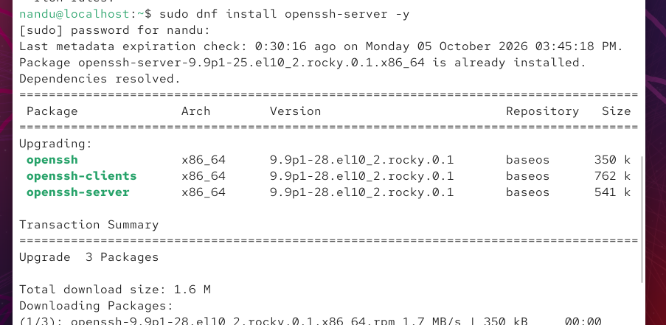

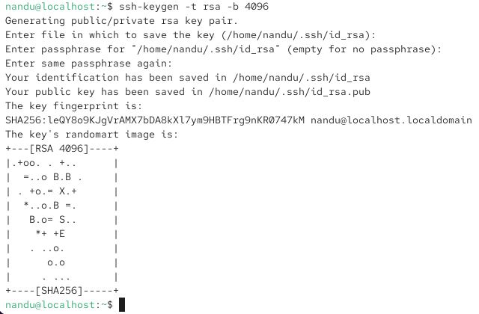

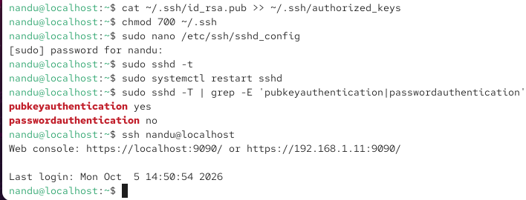

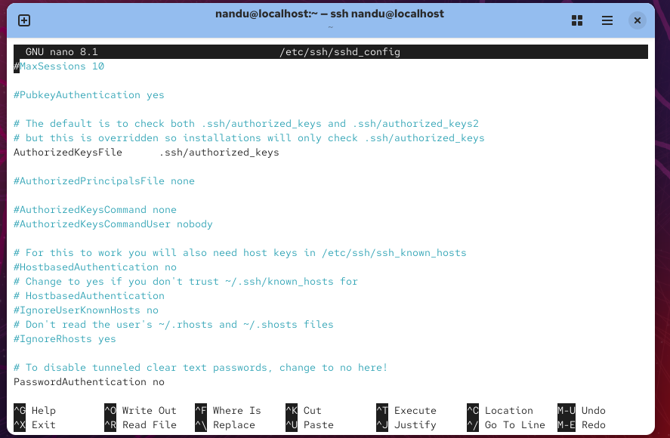

2. Set up a basic firewall using UFW or firewalld to allow only SSH (port 22) and HTTP (port 80) traffic, and block all other incoming connections. After applying rules, use a port scanning tool like nmap from another machine to verify only the allowed ports are open.

ANS:

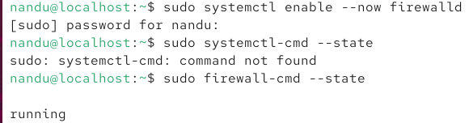

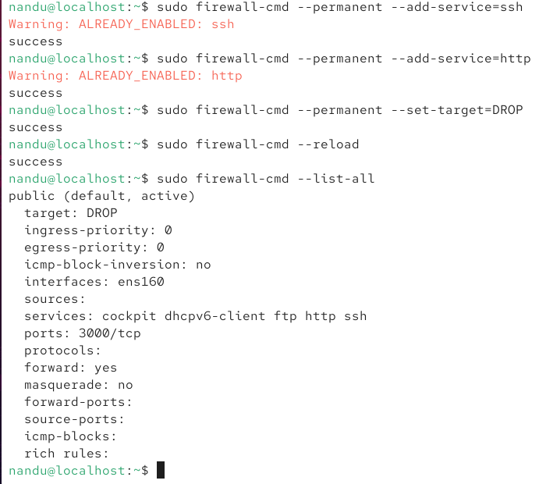

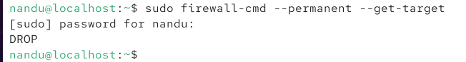

3. Write a shell script automate_backup.sh that creates a backup of your /home directory and saves it with a timestamp in /backups.

ANS:

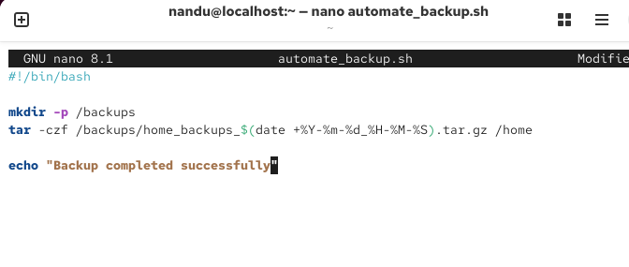
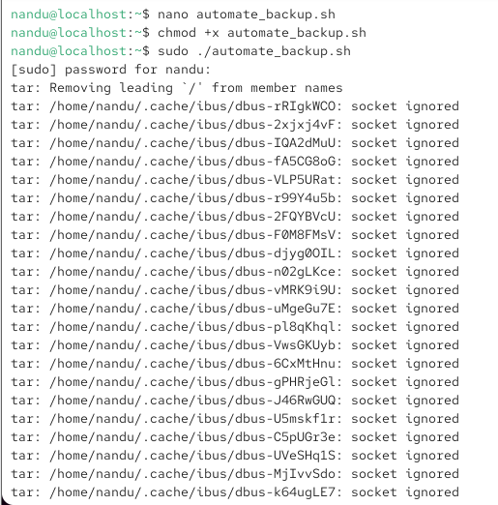

4. Check the current status of SELinux on your server, switch it to enforcing mode if it is not already, and verify the change using appropriate commands Use the commands getenforce and sete.nforce.

ANS:

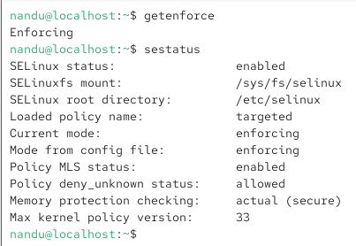

5. Use ChatGPT or Copilot to generate a checklist of at least 5 best practices for securing a Linux server, and compare it with your own server configuration to identify any missing steps.

ANS: Linux Server Security Checklist
- Keep system updated – Install security updates regularly.
- Enable firewall – Allow only required ports.
- Secure SSH – Disable root login and use SSH keys.
- Use strong permissions – Follow least-privilege access.
- Disable unused services – Reduce unnecessary attack surfaces.
- Monitor logs – Check login and system activity.
- Backup regularly – Maintain and test backups.

Compare with your server: Check which of these are already configured and mark the missing ones for implementation.

